Kingdoms

Kingdoms User Documentation

Team RED

Menu User- Documentation

Table of Contents

* Introduction…………………………………………………………1
* Main Menu………………………………………………………….2
* Deck Creator……………………………………………………….2
* Deck Selector………………………………………………………4
* Settings……………………………………………………………..5
* Quit………………………………………………………………….5
* Disclaimer…………………………………………………………..6

Introduction

This document details how the menus work within the kingdoms application. It will go over the main menu first, and then the sub-menus that are accessed through the main menu. This guide will also detail any special instructions that go along with the menus.

Main Menu

When you launch Kingdoms Card Game, the first thing you will see is the Main Menu Screen. This screen gives you several options.

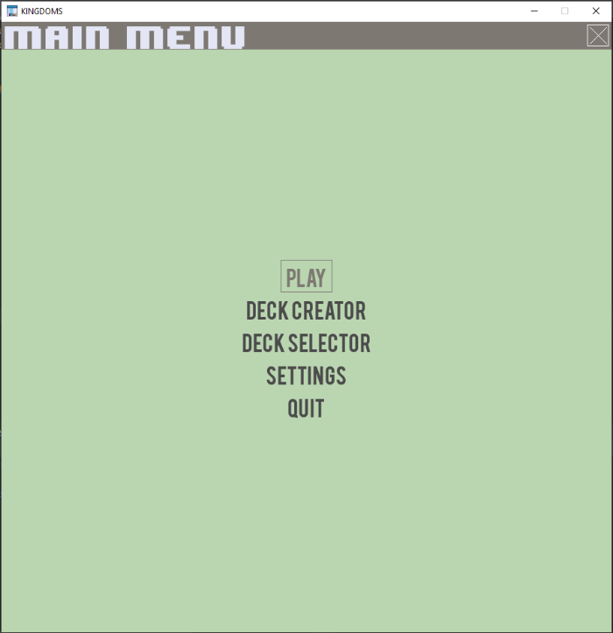

# Elements of the Main Menu

The main menu has five options to choose from. These are Play, Deck Creator, Deck Selector, Settings, and Quit. Each of these buttons will take you to a sub-menu that will give you options on how to set up your game. The remainder of this document will detail what each button does, and any special instructions that go along with that associated menu.

## Special Note about the Play Button

Because the application is still under development, the play button does not currently work. When the application is finished the play button will take you into the game, after you have selected or created your deck.

# Deck Creator

When the Deck Creator button is clicked, it takes you to the select a color screen. The options are Blue, Yellow or Back. Selecting Blue or Yellow will take you to the Deck Creator screen, the Back button will take you back to the Main Menu.

If you select Blue it will take you to the Deck Creator options for the blue deck. If you select Yellow, it will take you to the Deck Creator for the yellow deck.

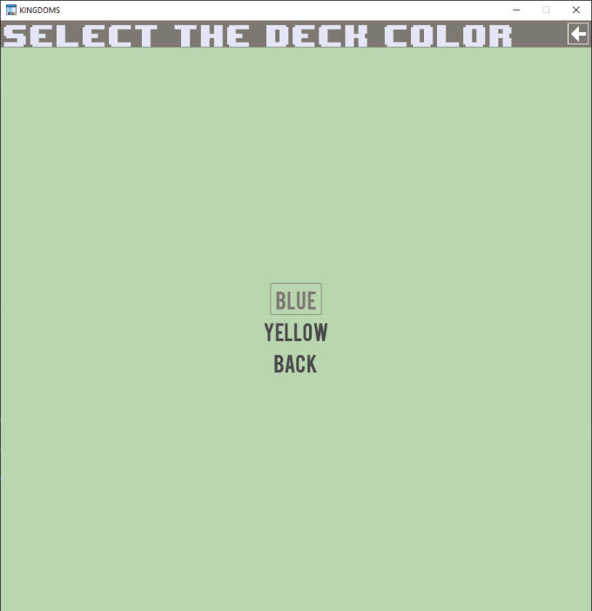

This is an example of one of the deck selector screens.

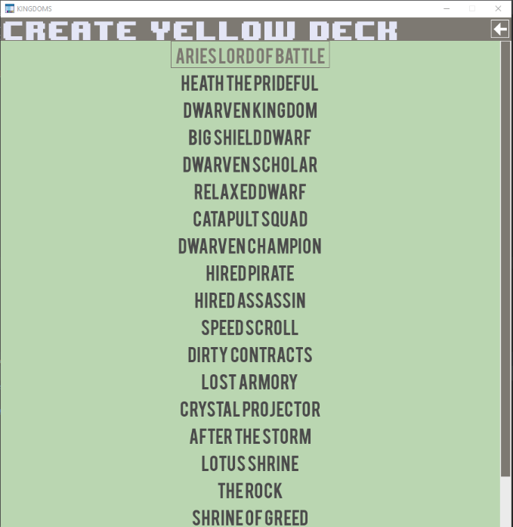

# Add Cards

On the Create Deck screen is where you will choose what cards that you want in your deck. Clicking on a name of a card will pull up another sub-menu that will give you a description of the card, and the option to add it to your deck, or go back.

Kin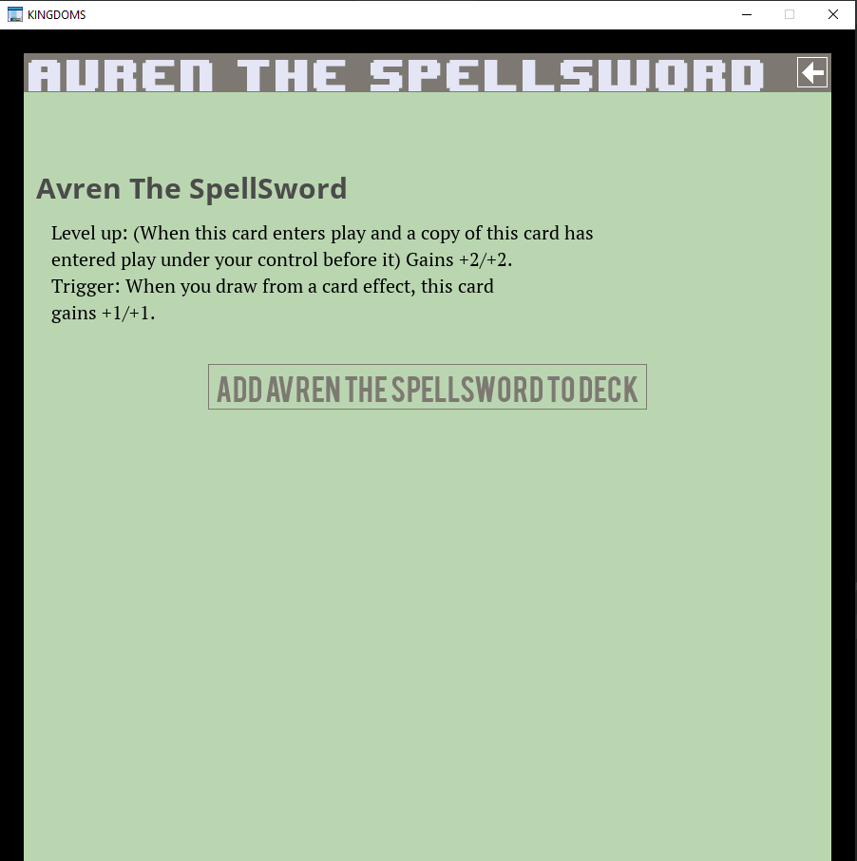

# Deck Selector

The Deck Selector screen is for when you have previously created a deck, and would like to use it in the game. When click on the Deck Selector it will pull up a drop down menu where you can choose which deck, as well as a save selection, and a back button.

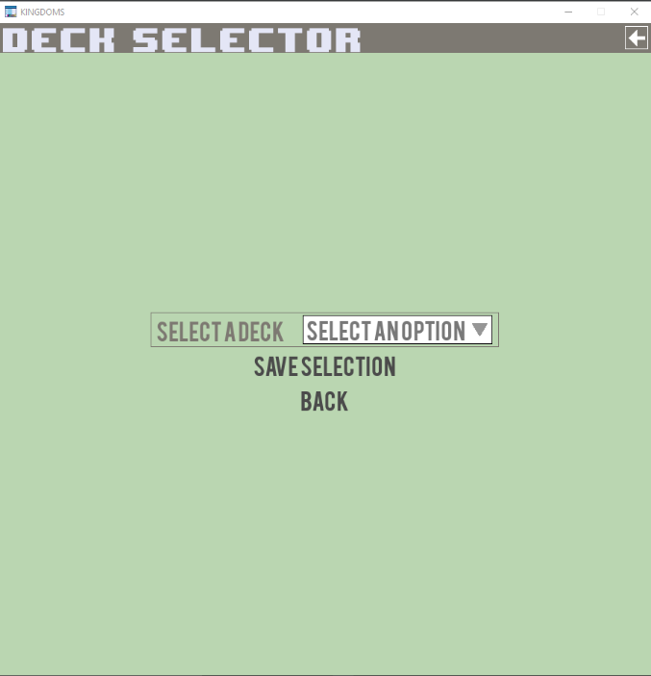

# Select a deck

If you click on the drop-down menu, it will give you the option of Blue, Red, or Yellow. These will only work if you have previously created decks that you wish to use. Simply click one of the options and hit save selection to select that deck to use in your game.

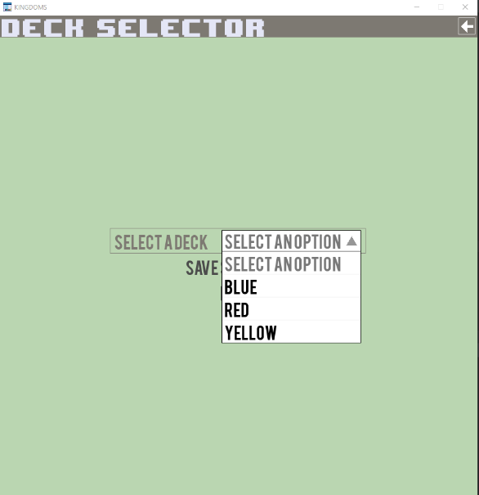

# Settings

The Settings Menu is where any game settings will be stored. It currently only has options for menu sounds, and Back. But more options will be added as the game is developed.

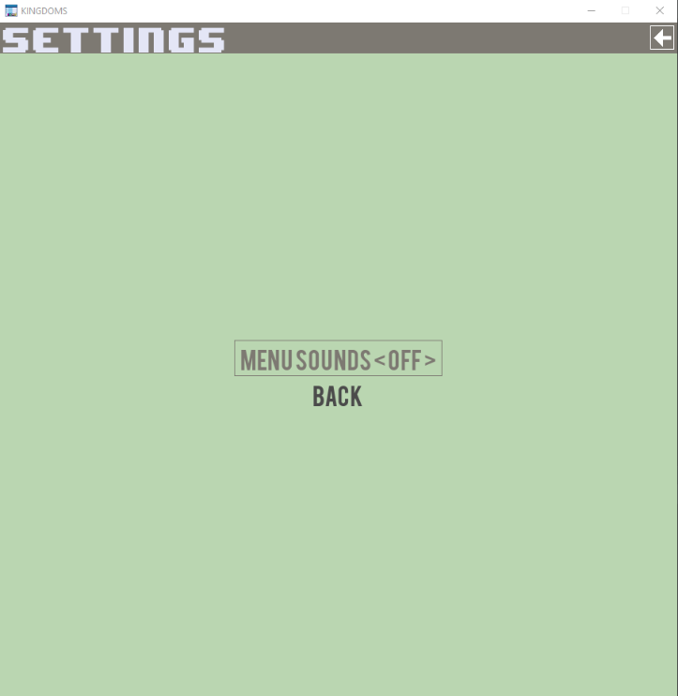

# Quit

If you hit the Quit button on the main menu, then it exits the game menu completely, and you will have to reload the application if you wish to continue using the game menu.

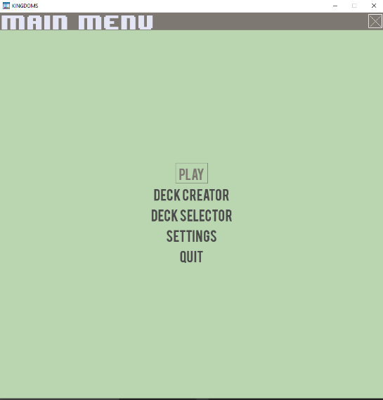

Disclaimer:

This project has been developed as part of a classroom learning experience by students at Utah State University.  While efforts are made to ensure copyrights and intellectual property rights have not been violated, it is the responsibility of the organization using any classroom projects created by USU and its students to make sure the materials contained therein do not infringe the property rights (including without limitation rights of privacy and publicity, trademark rights, copyrights, patents, trade secrets, and licenses) of third parties.